Brute force + os guide

Dependencies

Pip
This technically isn’t a dependency but will be used to install some of them.
Sudo apt install pip

Python
Sudo apt install python3

Psutil
Psutil is needed for the suid monitoring agent to function, it does not need to be configured as it is just a python library containing some built in functions to get process telemetry.
Sudo pip install psutil --break-system-packages
Check that it is importable the same way the pipeline runs it, this should print OK to the terminal:
sudo python3 -c "import psutil; print('OK')"

Watchdog
Watchdog is needed for the ssh_monitor, juice_monitor, and cron_monitor components and is another python library similar to psutil. It is primarily being used for file integrity monitoring.
Sudo pip install watchdog --break-system-packages
Check that it is importable the same way the pipeline runs it, this should print OK to the terminal:
python3 -c "import watchdog; print('OK')"

Cron
Cron should already be present on the system but check anyway. It is a Linux system process similar to the Windows task scheduler which runs processes automatically on boot and at fixed intervals. Cron runs with root privileges and if it is writable by a low privilege user it can be hijacked to execute malicious code with elevated privilege.
Sudo apt install cron

Openssh server
Openssh server is one of the services which the brute force attacks target and despite ssh itself being usable without it, the server module specifically needs to be installed for the attack to function.
Sudo apt install openssh-server -y
Sudo systemctl enable --now ssh
Check the status:
systemctl status ssh
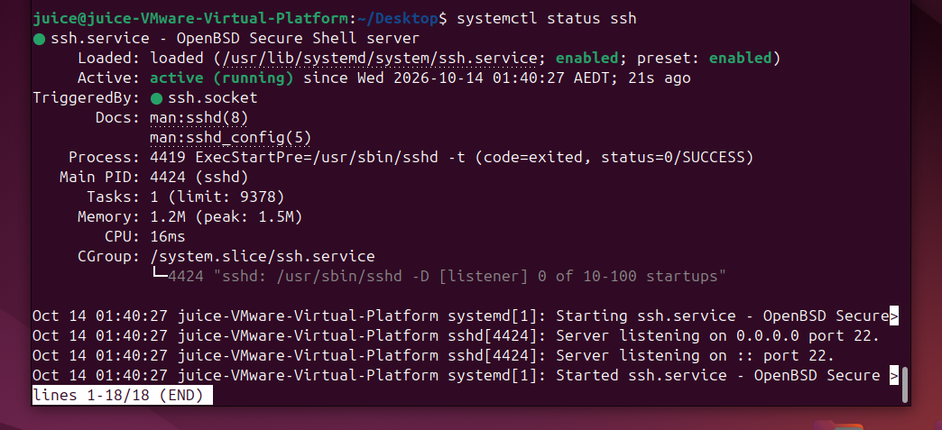

Nginx
NGINX is a reverse proxy which sits in front of the juice shop application and is configured here to capture and log network traffic directed at its port (8081). This is needed to generate the telemetry for the brute force attack against the juice login page. Important note: This requires that the attacker actually target the proxy port instead of just going to juice shops directly (port 3000), so to deal with this in a production environment port 3000 itself would be blocked making it so the only way to get to the web app would be through the proxy. This does create a fairly significant amount of resource utilization when there is a lot of network traffic, but it’s a pretty typical practice in industry.
Sudo apt install nginx
Installing nginx on it’s own isn’t enough, it needs to be configured to log things correctly.
Sudo nano /etc/nginx/nginx.conf
Add the following to the http {} block in /etc/nginx/nginx.conf:
log_format juice_login '$remote_addr [$time_iso8601] "$request" '
'$status BODY:$request_body';
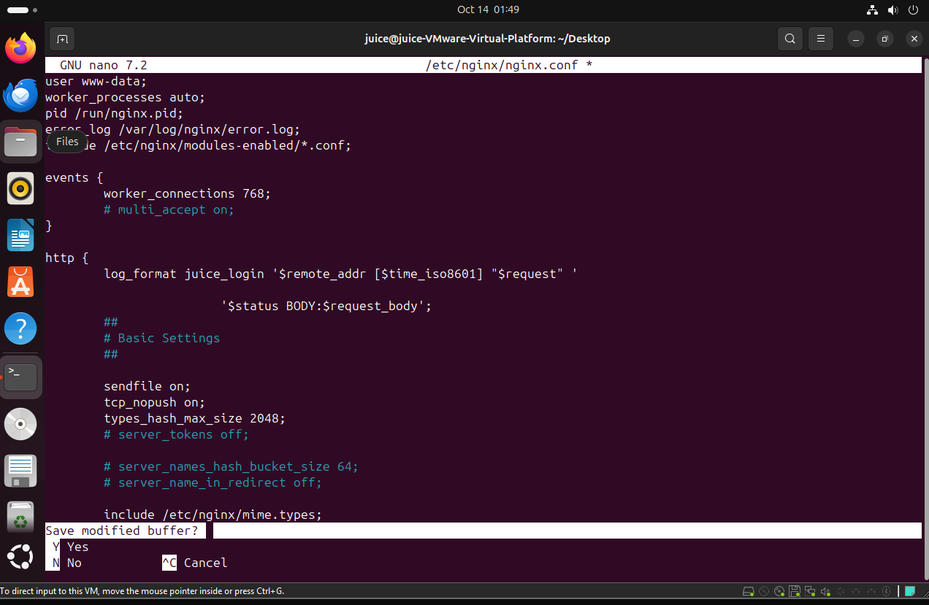
Now create /etc/nginx/sites-available/juiceshop-proxy:
sudo nano /etc/nginx/sites-available/juiceshop-proxy
Paste the following in the file:
server {
listen 8081;
access_log /var/log/nginx/juiceshop_access.log juice_login;
location / {
proxy_pass http://127.0.0.1:3000;
proxy_set_header Host $host;
proxy_set_header X-Real-IP $remote_addr;
}
}
Now enable the site, test the config file syntax, and reload nginx:
sudo ln -s /etc/nginx/sites-available/juiceshop-proxy /etc/nginx/sites-enabled/
sudo nginx -t
sudo systemctl reload nginx

Attacks

SSH password spray
A password spray targets multiple different accounts on a system with a small number of common passwords to get around detection logic that relies on the same account being targeted over and over again.

Setup
Requires:
- Openssh server
- Hydra
- Username list
- Ssh_monitor.py
- Brute_force_detection.py
- Brute_force_response.py
On Juice, check the status of openssh server:
Systemctl status ssh
It should show as enabled like in the screenshot in dependencies.
Ensure that the EDR modules are running:
./start.sh
pstree -p $(cat .edr1-runtime/pids/brute-force.pid)
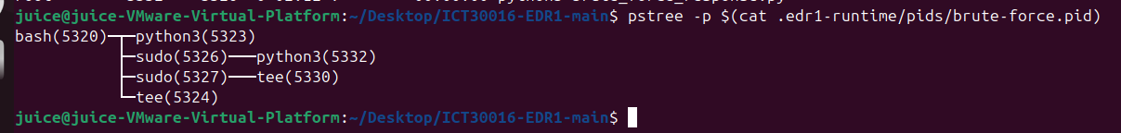
Tail the log to make sure it is being appended:
tail -n 50 .edr1-runtime/logs/brute-force.log
If you see the following it means that watchdog doesn’t have root privileges and needs to be install properly with the pip command in the dependencies section.
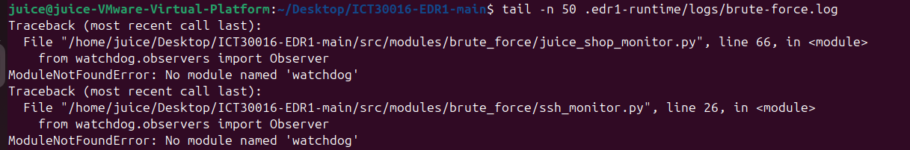
After reinstalling watchdog, restart the EDR, tail edr_bruteforce_facts.jsonl, and then try to ssh in with a bad password to see if it is being appended. Output should look like:
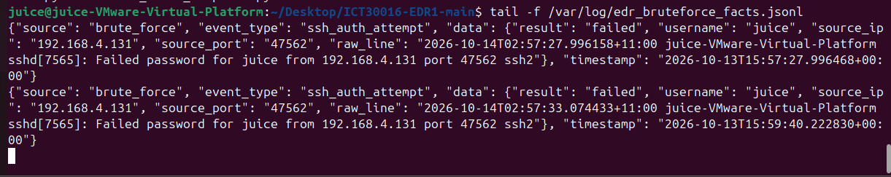
Next make some dummy accounts on the Juice VM for the attack to target, 3 is sufficient for the detection logic to recognize it as a password spray.
sudo adduser target1
It’s fine to make the password the same as the username, no need to add any other details, just hit enter until you’re prompted [y/n] and respond y.
On Kali, make a text file called userlist.txt and populate it with the names of the target accounts, one per line.
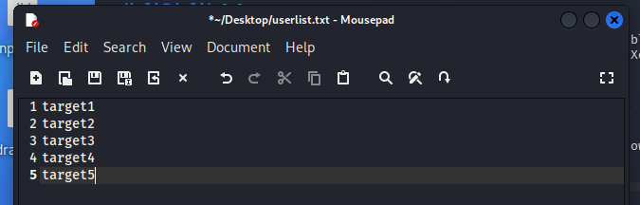
Make another text file called passlist.txt with 2-3 passwords in it, they don’t need to be correct.
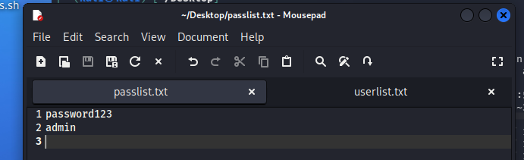

Attack
On Kali:
Open a terminal and navigate to the location of userlist.txt and passlist.txt.
Hydra -L userlist.txt -P passlist.txt -u ssh://<juice ip> -t 4 -V
-L specifies the login username, -P the password, -t specifies the speed (higher number is faster), and -V makes it print each login attempt to the terminal.
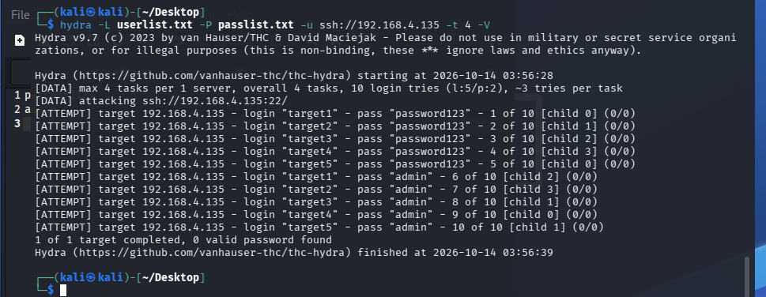
The alert should say that it is a password spray:
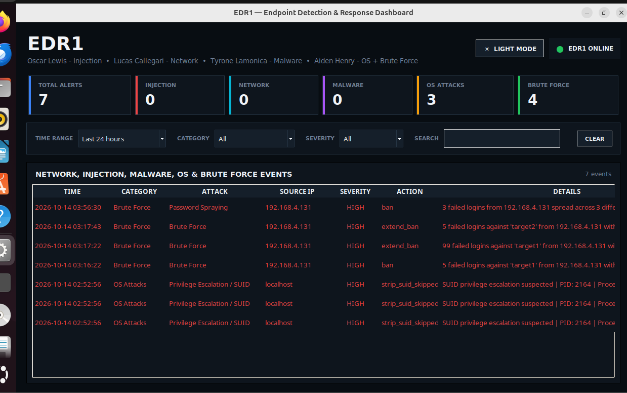
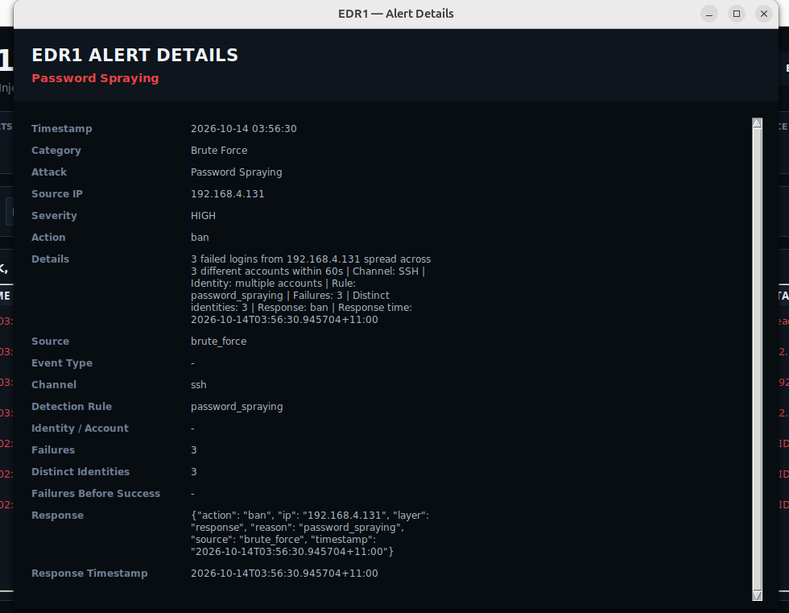

Juice credential stuffing

Cron hijacking

SUID abuse

